Troubleshooting Microsoft Teams performance

If your Teams app is slowing down when you are on a video call or sharing a screen in a meeting, the issue could be caused by different reasons – the service from Microsoft, your device, the Teams app itself or your Internet connection.
This guidance is for you to be able to check some of these things yourself and self-troubleshoot instead of having to raise a ticket on FirstPoint.
We have arranged the guidance in a way that lets you first try some easy fixes that are likely to help, then progressing to more technical troubleshooting.
However, the contents table below is arranged in themes in case you want to try the ‘device’ fixes as a whole or the ‘Teams app’ fixes as a whole before anything else.
Click on anything with a page number to reach that page.

Table of Contents
Microsoft Service 2
Your device – things you can check about your laptop/computer
Restart device 3
Install all Windows updates 4
Close background apps 7
Clear storage in C drive 8-10
Teams App – things you can do within Teams itself
Install all Microsoft Teams updates 3
Tick ‘Disable GPU hardware acceleration’ box 5-6
Stop using blur or custom background in meetings 6
Tick the ‘turn off animations’ box 11
Use Teams in web app instead of desktop 12
Reset Teams cache 12-13
Connectivity (Network) 14

Microsoft Service
You can quickly check whether there are any global Teams service issues here:
Service Status (office.com)
This will open the Microsoft service health dashboard in your web browser (Edge, Chrome).
Click on Teams to see is everything is okay globally. It likely will be fine but is worth taking a minute to check.

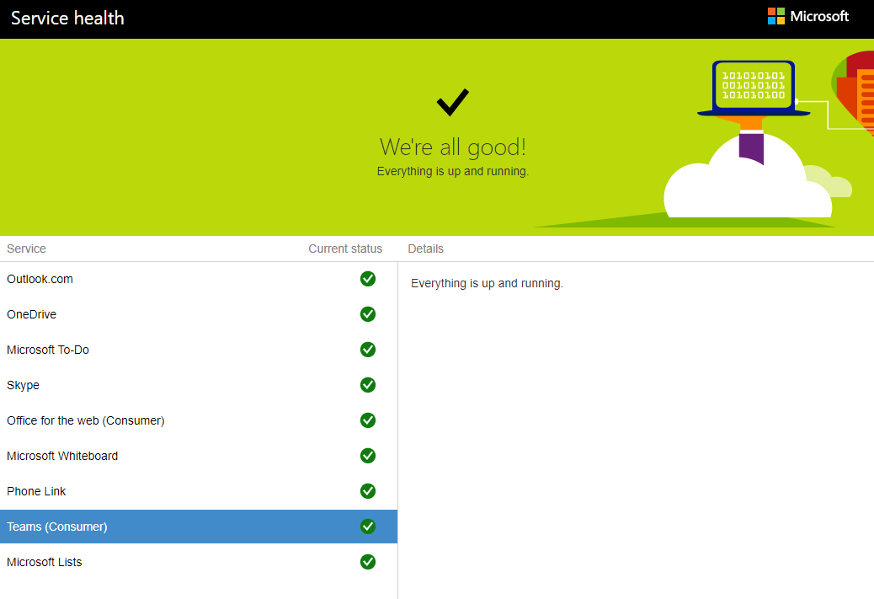

Restart your laptop/computer
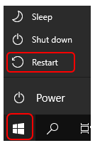
If your device hasn’t been restarted in a while, it may be waiting to install updates for Windows and your applications.
You should regularly restart to ensure that any background tasks are completed, and your device starts up cleanly.

Install all available updates within the Teams app
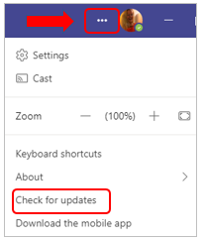
- In Teams, select the ‘Settings and more’ ellipsis (…) in the top right-hand corner of your Teams window.

- Click ‘Check for updates’

- A message will appear along the top of the window:

You can continue to work and any waiting updates will be installed.

Install all available Windows updates on your laptop/computer
- Select the Start button, then go to Settings. (You can also use the shortcut of Windows key plus I key)

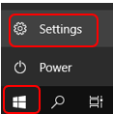

- Choose the ‘Update & Security’ section.
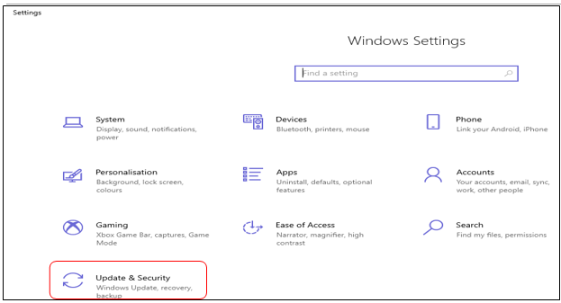
- Choose ‘Windows Update’ heading on the left.

- Click ‘Check for updates’.
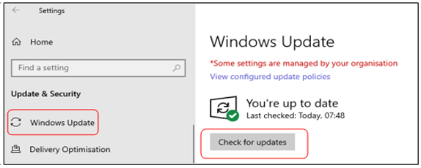
- Restart your computer if prompted.

Tick the ‘Disable GPU hardware acceleration’ option in Teams
GPU is short for ‘graphics processing unit’ and this can be disabled easily in Teams with no obvious impact to your use of the app. In fact, doing so can improve your laptop’s ability to run Teams, although you might notice that lines and shapes are not as clearly defined.
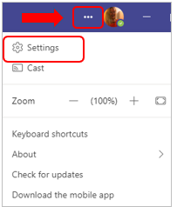
- Select the ‘Settings and more’ ellipsis (…) in the top right-hand corner of your Teams window.

- Click Settings.

- In the General settings, under the Application section tick the box next to ‘Disable GPU hardware acceleration’.
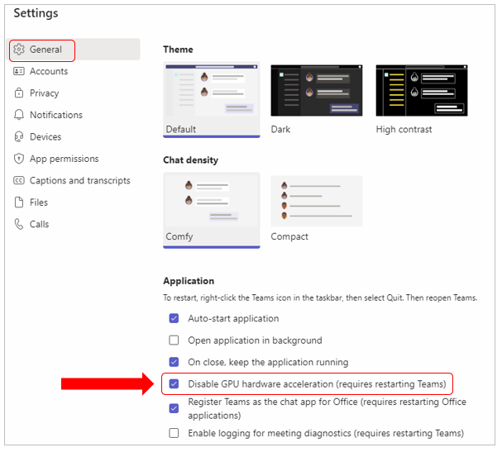

- To enable this change, you will need to restart Teams but you must close it via your system tray in bottom right of your computer screen (e.g. where your time and date is).

- Click onto the small upwards arrow, right click on the Teams icon and choose Quit.

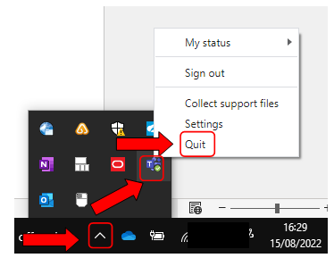

- Re-open Teams from the Start Menu.

Switch off background blur and background images when in a meeting
Blurring your background when your camera is on or setting an image behind you for meetings uses extra resource on your device because it has to adjust the background each time you move.
If you are able to, switch these off and have your actual background showing if your Teams app is slow.

Manage the background applications on your laptop/computer
You can check which applications are using a lot of resource on your device.
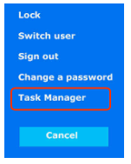
- Press Ctrl key and Alt key plus Delete key (Ctrl+Alt+Del), then choose Task Manager from the list that appears on your screen.

- Once in Task Manager, you can check the CPU and memory usage to identify and close any background applications using excessive resources.
(CPU is ‘central processing unit’ and in basic terms is what takes the input, processes it and creates the outputs.)
Note: you can click onto a column heading and it will put the highest at the top.
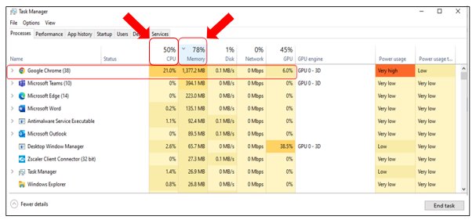
You may want to close any high-usage apps and browsers you are not using during your Teams call.
- To free up memory and CPU usage, click onto an app you are not using and click ‘End Task’ at the bottom right.
- In addition, if you are someone who keeps a lot of tabs open on your web browser (Edge or Chrome), you should think about closing tabs when not using them. Having too many open can impact both CPU and Memory.

Check and create available storage on C drive on your device
You can check the available disk space left on your laptop’s C:\ drive through File Explorer.
- File Explorer is the folder icon on your taskbar, or you can use the shortcut of Windows key plus E key to open your File Explorer directly.

- Click on ‘This PC’ on the left
- Look at the ‘Windows (C:)’ section on the right.
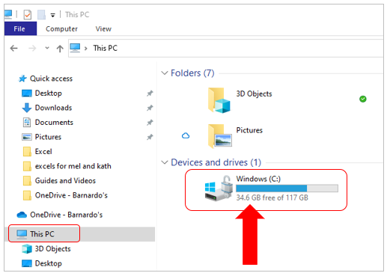

- If less than 15GB is free, you can run through the following tasks to free up space:

- Delete any old mails from your Outlook mailbox that you no longer need (particularly those with attachments). You can check the size of your mailbox by following this guide –
What’s the size of my mailbox? (microsoft.com)
Remember that you can move Outlook items into your OneDrive too. As your OneDrive is in the cloud, they will no longer take up space on your C drive.

- Empty your recycle bin - this is on your desktop. You can do this by right clicking on the icon and choosing ‘Empty’ or by opening the recycling bin and manually selecting files to delete.
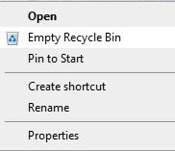

- Move files into the cloud. If you have files/folders showing in your OneDrive with an icon that is a green tick on a white circle, this means they are being store ‘locally’ on your laptop so are using space on the C drive.
You can tell this both from the small tick icon and when you hover over that document name, it will say ‘Available on this device’.
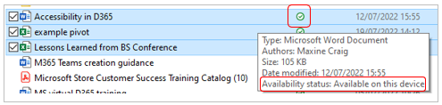

By right-clicking on a file or folder and selecting ‘Free up space’, this will move the folder/file to the cloud and will free up space on your device. The icon will change to a cloud.

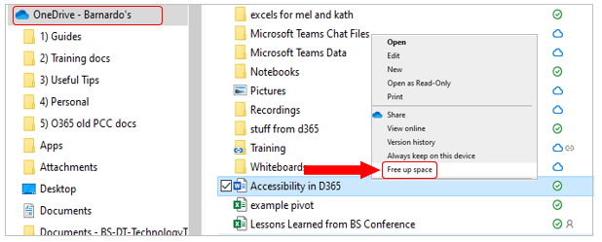
Because we use Microsoft 365, Cloud files and folders are still available to you and will remain in your OneDrive list.

- Manage your downloads. Delete any unrequired files from your Downloads folder or move them into your OneDrive where they will be in the cloud.

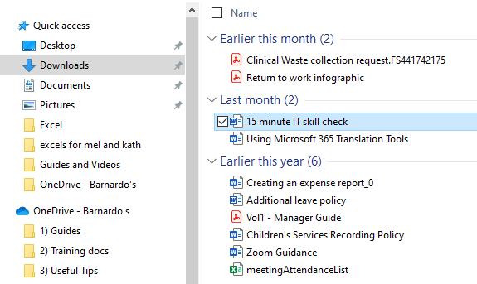

- Clear your temporary files. During normal usage, your applications use temporary files whilst processing data. Generally, these are cleaned up when you exit the application but some can remain, particularly if the application doesn’t close cleanly.
You can remove these manually by deleting .TMP files from the temporary location (%Temp%).

Close all open applications, open File Explorer and input %Temp% into the address bar. Then press enter:

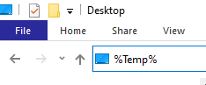

Sort based on Type and scroll down to the files that have .tmp at the end of their name and delete them.
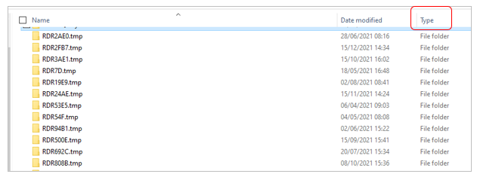
Press ‘Skip’ if you get any files flagged as ‘in use’.
Note: there could be thousands.

Tick the ‘Turn off animations’ box in Teams
You can switch off animations on Teams. This means that, although GIFs can still be seen, they will not play automatically.
- Select the Settings and more ellipsis (…) in the top right-hand corner of your Teams window

- Click Settings

- In the General settings, under Display section tick the box next to ‘Turn off animations’.
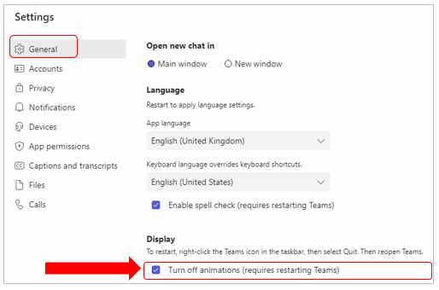
- To enable this change, you will need to restart Teams from the icon tray in bottom right of your screen.

- Click onto the small upwards arrow, right click on the Teams icon and choose Quit.

- Open Teams from the Start Menu

Note: this setting will likely revert to unticked if you sign out of Teams. It does not revert if you remain signed in and shut down your laptop.

Use Teams web app instead of desktop app
As with all Microsoft 365 apps, there is a desktop version of Teams and an online/web version.
You could try the Teams Web App instead of desktop app to see if you have a better experience.
The web version has some functional limitation so just make sure you don’t need to undertake the following in your meeting:
- share a video on-screen or take control of a screen someone else is sharing (unless it is a PowerPoint)
- create breakout rooms (but you can join one)
- start a Whiteboard (but you can sketch on one)
- use the noise suppression function

Reset the Teams cache
You can clear the Teams cache to see if this will speed things up. A cache is just a memory in Teams to improve the retrieval of data.
Note: if you do this, it will remove some local Teams settings such as any custom backgrounds that you have added yourself for your meetings. However, your chats and stored personal files will be unaffected.
- Close and quit Teams from the icon tray by clicking onto the upward arrow, right clicking onto the Teams icon and choosing Quit.
- If you have Microsoft Outlook Desktop App open, close that too because it has a Teams add-in.

- Using the File Explorer, type or paste in the following file path %appdata%\Microsoft into the top bar and pressing Enter on your keyboard.

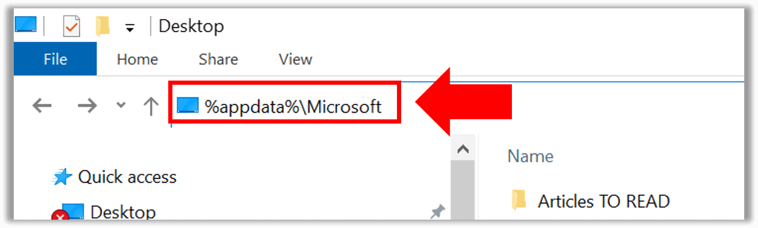

- Delete the Teams folder by right clicking onto it and choosing Delete. Only delete the Teams folder.
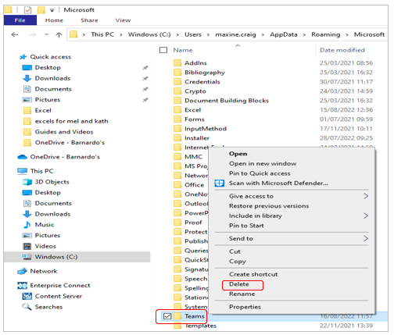

- Open Teams from the Start Menu.

Connectivity

Network -
You can test Teams on an alternative network connection e.g., another Wi-Fi access point, mobile tethering if you know how to do this (if not, see link below to inside Barnardo’s page)
https://inside.barnardos.org.uk/resources-and-guidance/our-it/getting-connected/tethering-and-personal-hotspot

