Update Stronger from the Start Infant Mental Health Alliance
Members of the Stronger from the Start IMH Alliance (SFTS) are extremely concerned about the impact the current Cost of Living crisis is having on parent/infant relationships and the impact this will have both in the short and long term.
Roberta Marshall SFTS Chair spoke about this at the Crushed by the Cost of Living event on 21st September at the Long Gallery, Parliament Buildings.
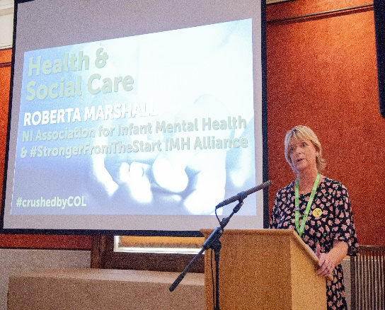
Following on from this event and the concerns already raised at the ‘Poverty and Infant Mental Health: Understanding the relationship, challenging the status quo’ event in June organised by The Association for Infant Mental Health NI (AIMH NI) and SFTS IMH Alliance, we took the decision to write to local leaders to reiterate our message on the importance of the 1st 1001 Days and the detrimental impact poverty can have on relationships at this crucial time. All SFTS member agencies were in support of this and letters were sent to Minister of Health, Mental Health Champion, NICCY and the five main Party Political Leaders. You can read the letter here.
We received various responses which we are now following up on – the first action was a meeting with Paula Bradshaw, Nuala McAllister, Nick Mathison and Maeve Donnelly of the Alliance Party. We met at Parliament Buildings to discuss the importance of including infants in policymaking, strong parent and infant relationships and infant mental health in the context of the cost of living crisis.
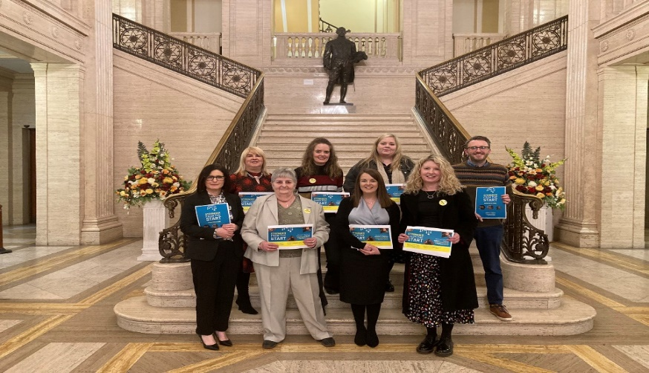
If your organisation is interested in joining us to advocate for the strong mental health and emotional wellbeing of all infants in Northern Ireland, please contact Eilish.robinson@barnardos.org.uk
Roberta Marshall
SFTS Infant Mental Health Alliance Chair

